Experiment 13
Title
Demonstrate Infrastructure as a Service (IaaS) by creating a Resource Group using Microsoft Azure and configuring minimum CPU, RAM, and Storage resources.
Aim
To create a Resource Group in Microsoft Azure for organizing cloud resources and preparing infrastructure with minimum CPU, RAM, and storage requirements.
Procedure
- Log in to the Azure Portal.
- Select Resource Groups from the Azure dashboard.
- Click Create Resource Group.
- Choose the subscription.
- Enter the Resource Group name (e.g., RG-IaaS-Lab).
- Select a region.
- Click Review + Create.
- Verify the details and click Create.
- After successful deployment, view the created Resource Group.
Output
A new Azure Resource Group was successfully created and is ready to host cloud resources such as Virtual Machines, Storage Accounts, and Networks.
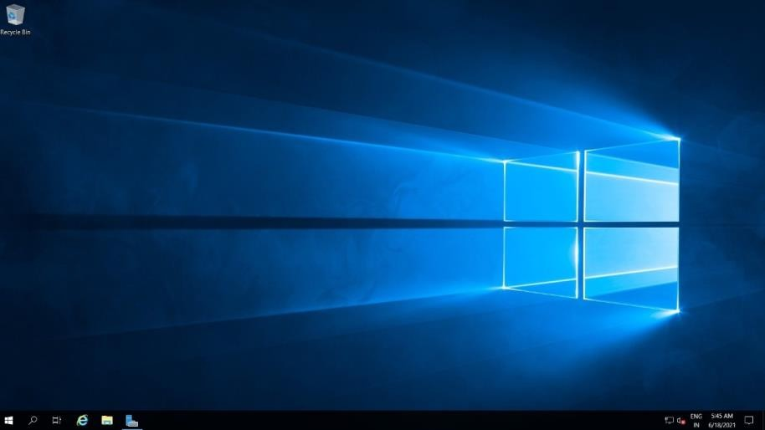
Screenshot

Result
Successfully created an Azure Resource Group for managing IaaS resources.

Experiment 14
Title
Demonstrate Infrastructure as a Service (IaaS) by creating a Virtual Machine using Microsoft Azure with required CPU and Memory.
Aim
To create and configure an Azure Virtual Machine with specified CPU, RAM, and storage.
Procedure
- Log in to Azure Portal.
- Navigate to Virtual Machines.
- Click Create → Azure Virtual Machine.
- Select the Resource Group created earlier.
- Enter VM name.
- Choose Operating System (Windows/Linux).
- Select VM Size:
  - CPU: 1 vCPU
  - RAM: 1 GB or above
- Configure authentication (Password/SSH Key).
- Configure storage and networking settings.
- Click Review + Create.
- Click Create to deploy the VM.
Output
The Virtual Machine was successfully deployed with the specified CPU and RAM configuration.

Screenshot
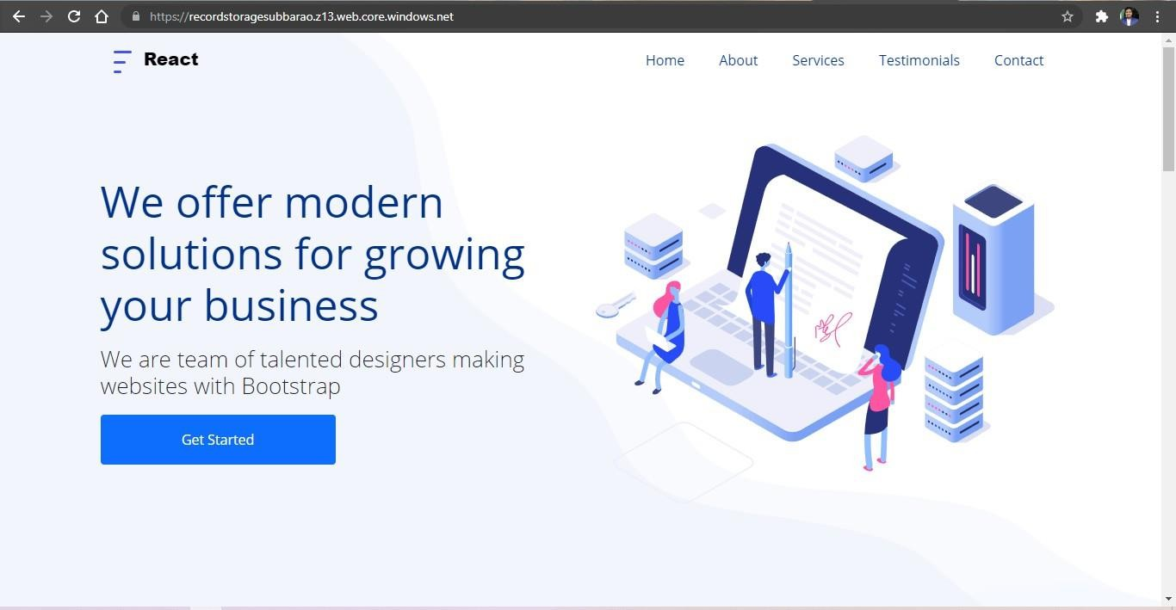
Result
Successfully created and configured an Azure Virtual Machine.

Experiment 15
Title
Demonstrate Infrastructure as a Service (IaaS) by establishing remote connection and launching the created Virtual Machine.
Aim
To connect remotely to an Azure Virtual Machine and access its desktop environment.
Procedure
- Open Azure Portal.
- Navigate to the created Virtual Machine.
- Start the VM if it is stopped.
- Copy the Public IP Address.
- For Windows VM:
  - Click Connect → RDP.
  - Download the RDP file.
  - Open the file and enter credentials.
- For Linux VM:
  - Use SSH client.
  - Connect using:
Bash
ssh username@public-ip-address
- Verify successful login.
Output
Successfully established remote connection and accessed the Virtual Machine desktop/terminal.
Screenshot
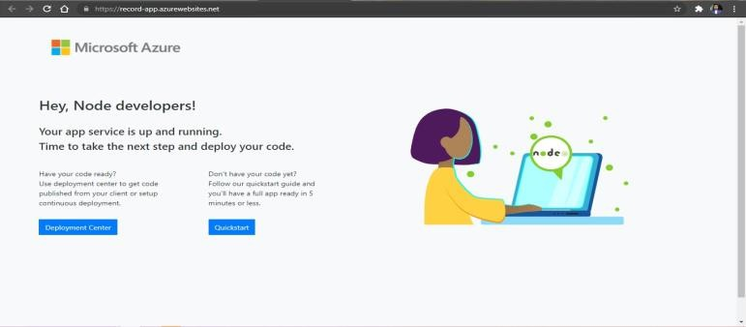
Result
Successfully connected to and operated the Azure Virtual Machine remotely.

Experiment 16
Title
Demonstrate Platform as a Service (PaaS) by creating and configuring a Web App Service in a Public Cloud Provider.
Aim
To create and configure a Platform as a Service (PaaS) environment using Azure App Service.
Procedure
- Log in to Azure Portal.
- Search for App Services.
- Click Create App Service.
- Select Subscription and Resource Group.
- Enter Application Name.
- Select Runtime Stack:
  - Python / Java
- Choose Operating System.
- Select Pricing Plan.
- Click Review + Create.
- Deploy the App Service.
Output
A PaaS-based Azure App Service was successfully created and configured.
Screenshot
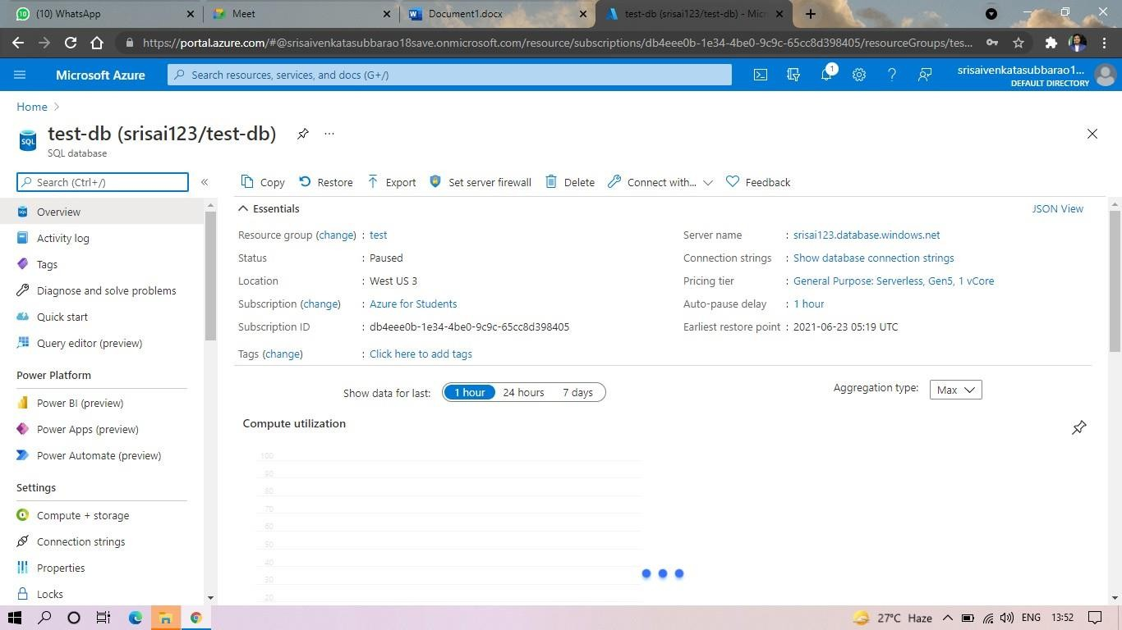
Result
Successfully created and configured a PaaS environment using Azure App Service.

Experiment 17
Title
Create a Simple Web Application using Python and Host it on Azure App Service (PaaS).
Aim
To develop a simple Python web application and deploy it on Azure App Service.
Procedure
Step 1: Create Python Application
Create file app.py
Python
Run
from flask import Flask
app = Flask(__name__)
@app.route('/')
def home():
return "Hello Azure Cloud!"
if __name__ == '__main__':
app.run()
Step 2: Install Flask
Bash
pip install flask
Step 3: Test Application Locally
Bash
python app.py
Step 4: Deploy to Azure App Service
- Create App Service.
- Configure Runtime as Python.
- Upload application files using GitHub/VS Code Deployment.
- Start the application.
- Access the generated URL.
Output
The application was successfully hosted and displayed:
Hello Azure Cloud!

Screenshot

Result
Successfully developed and hosted a Python web application using Azure App Service.

Experiment 18
Title
Demonstrate Storage as a Service (STaaS) using Azure Storage Account.
Aim
To create and configure a Storage Account in Microsoft Azure and store files in the cloud.
Procedure
- Log in to Azure Portal.
- Search for Storage Accounts.
- Click Create.
- Select Subscription and Resource Group.
- Enter Storage Account Name.
- Choose:
  - Performance: Standard
  - Redundancy: LRS
- Click Review + Create.
- Create the Storage Account.
- Open the Storage Account.
- Create a Container.
- Upload files into the container.
- Verify successful upload.
Output
Storage Account and Blob Container were successfully created, and files were uploaded to cloud storage.
Screenshot
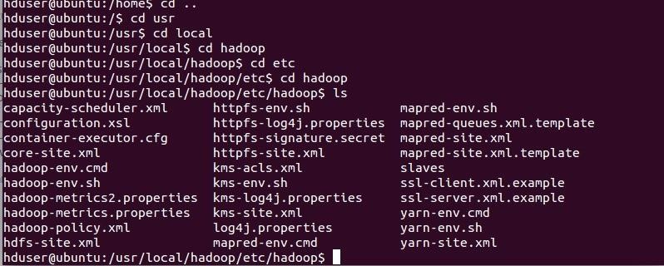
Result
Successfully demonstrated Storage as a Service (STaaS) using Azure Storage Account.

